# Grid Plots

Grids are general types of plots that allow you to map plot types to rows and columns of a grid, this helps you create similar plots separated by features.

## PairGrid

Pairgrid is a subplot grid for plotting pairwise relationships in a dataset.

# Just the Grid

sns.PairGrid(iris) – will give the subplots same as pair plots but empty ones

import seaborn as sns  
import matplotlib.pyplot as plt  
iris = sns.load_dataset("iris")  
g = sns.PairGrid(iris)  
g.map(plt.scatter)  
plt.show()

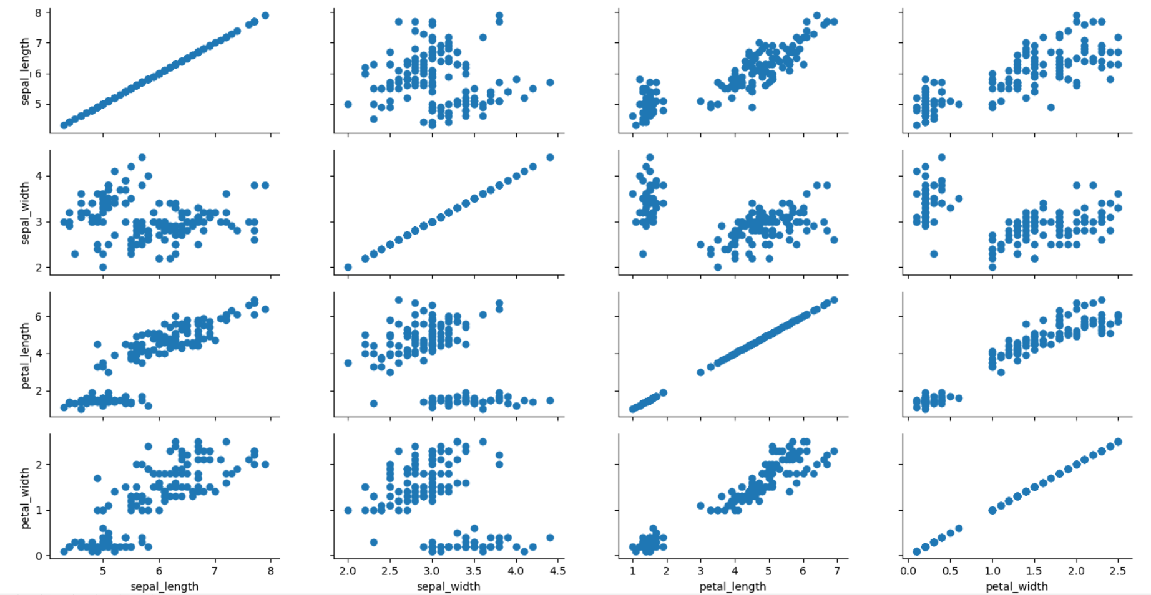

We can also specify different plots to different portions such as

import seaborn as sns  
import matplotlib.pyplot as plt  
iris = sns.load_dataset("iris")  
g = sns.PairGrid(iris)  
g.map_diag(sns.distplot)  
g.map_upper(plt.scatter)  
g.map_lower(sns.kdeplot)  
plt.show()

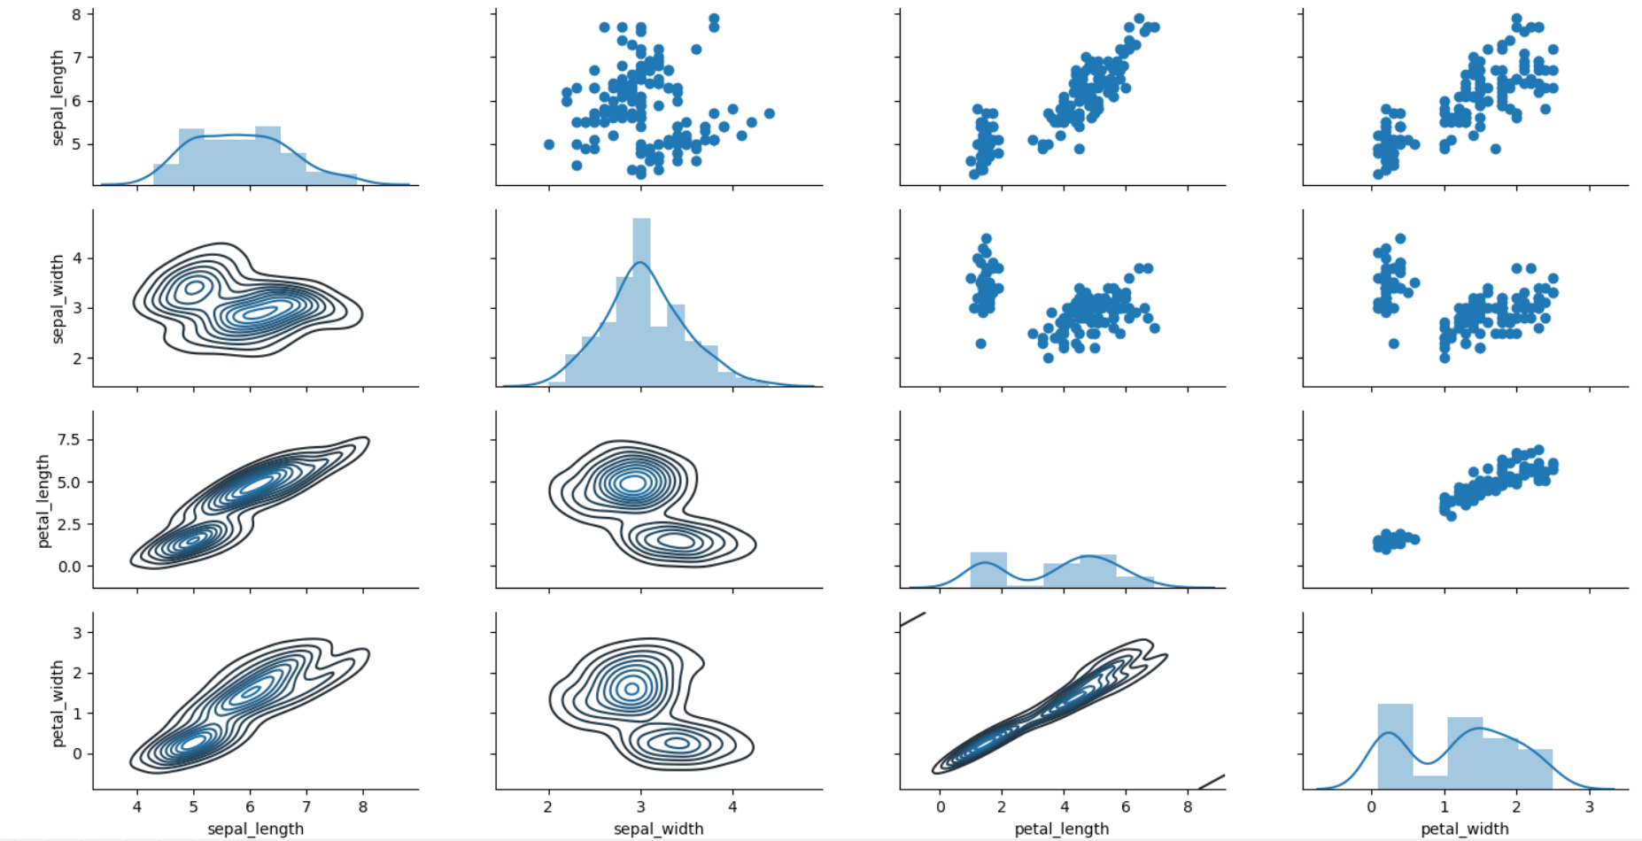

## pairplot

We can also make customisations to pairplot such as hue and palette

import seaborn as sns  
import matplotlib.pyplot as plt  
iris = sns.load_dataset("iris")  
sns.pairplot(iris,hue='species',palette='rainbow')  
plt.show()

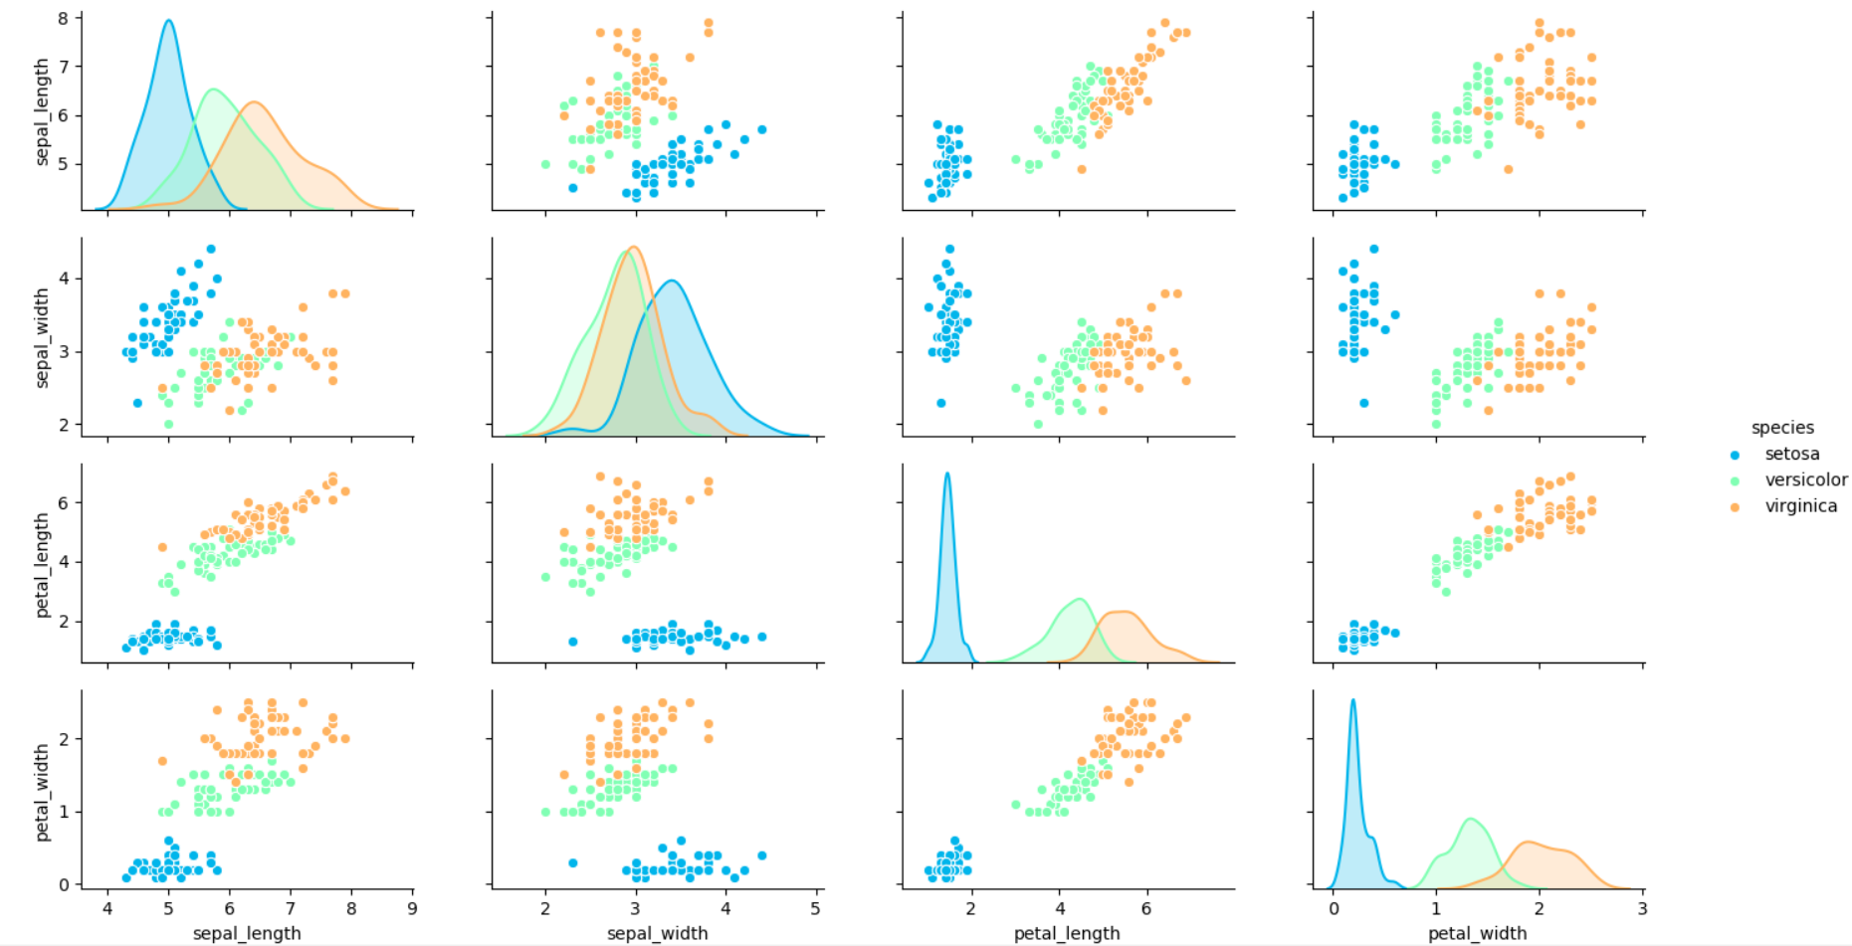

## FacetGrid

FacetGrid is the general way to create grids of plots based off of a feature

import seaborn as sns  
import matplotlib.pyplot as plt  
tips = sns.load_dataset('tips')  
# Just the Grid  
g = sns.FacetGrid(tips, col="time", row="smoker")  
plt.show() Produces empty grid since we have not mapped any plots yet to it

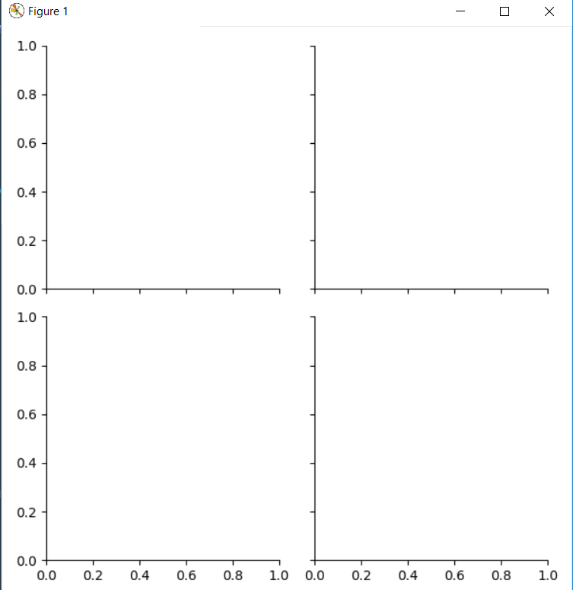

Here it will plot scatter plots where rows have smoker values yes or no and columns has time value, lunch and dinner

import seaborn as sns  
import matplotlib.pyplot as plt  
tips = sns.load_dataset('tips')  
g = sns.FacetGrid(tips, col="time", row="smoker")  
g = g.map(plt.hist, "total_bill")  
plt.show()

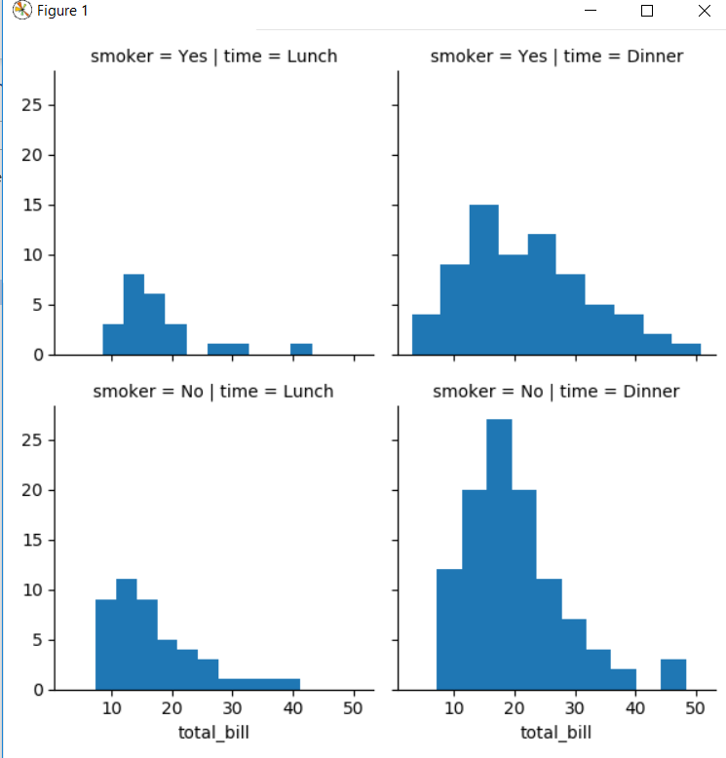

We can also map those plots to facetgrip which require two arguments and arguments can be passed one after the another.

import seaborn as sns  
import matplotlib.pyplot as plt  
tips = sns.load_dataset('tips')  
g = sns.FacetGrid(tips, col="time", row="smoker",hue='sex')  
# Notice hwo the arguments come after plt.scatter call  
g = g.map(plt.scatter, "total_bill", "tip").add_legend()  
plt.show()

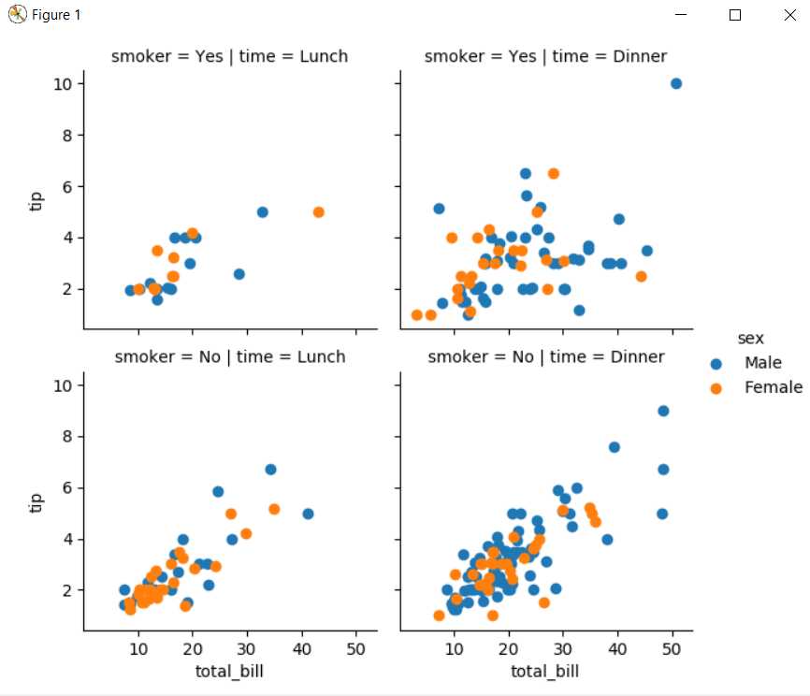

## JointGrid

JointGrid is the general version for jointplot() type grids, for a quick example:

import seaborn as sns  
import matplotlib.pyplot as plt  
tips = sns.load_dataset('tips')  
g = sns.JointGrid(x="total_bill", y="tip", data=tips)  
g = g.plot(sns.regplot, sns.distplot)  
plt.show()

